IBM PROJECT REPORT
ON
“Machine Learning–Based Prediction of Breast Cancer Survival Using Clinical and Diagnostic Data”
SUBMITTED IN PARTIAL FULFILLMENT OF REQUIREMENT FOR DEGREE OF

BACHELOR OF TECHNOLOGY COMPUTER SCIENCE & ENGINEERING
(Artificial Intelligence and Machine Learning)

Developed By :- Guided By :-

SAKSHI KHANDU – 220220159 Mr. Harsh Trivedi
PRIYANSHI VISHWAKARMA – 220220222
RITIK VISHWAKARMA– 220220223
VAIBHAVI KUMBHAR– 220220226
SHIVAM MISHRA– 220220209



DEPARTMENT OF COMPUTER SCIENCE AND INFORMATION TECHNOLOGY
CHHATRAPATI SHIVAJI MAHARAJ UNIVERSITY
PANVEL, NAVI MUMBAI

[2026]

DEPARTMENT OF COMPUTER SCIENCE AND INFORMATION TECHNOLOGY
CHHATRAPATI SHIVAJI MAHARAJ UNIVERSITY
PANVEL, NAVI MUMBAI

[2026]



Certificate
This is to certify that the IBM Project work entitled "Breast Cancer Detection" by Sakshi Khandu (Enrolment No.220220159), Priyanshi Vishwakarma (Enrolment No.220220222),Ritik Vishwakarma (Enrolment No.220220223), Vaibhavi Kumbhar (Enrolment No.220220226) and Shivam Mishra (Enrolment No.220220209) of Chhatrapati Shivaji Maharaj University , towards the partial fulfilment of requirements of the degree of Bachelor of Technology Computer Science and Engineering, carried out by them in the CSE(AIML) Department. The results/findings contained in this Project have not been submitted in part or full to any other University/Institute for award of any other Degree/Diploma.
____________  Mr. Harsh Trivedi | ______________  (Head of Department)  Mr. VIKAS KUMAR

Project Report Approval for B. Tech

This project report entitled “Breast Cancer Detection” by “ SAKSHI KHANDU, PRIYANSHI VISHWAKARMA, RITIK VISHWAKARMA, VAIBHAVI KUMBHAR, SHIVAM MISHRA” is approved for the degree of Bachelor of Technology in Computer Science Engineering (Artificial Intelligence and Machine Learning).

Examiners

1.

2.

Date: 05-05-2026
Place:

ACKNOWLEDGEMENT

IBM/Industry Internship project is a golden opportunity for learning and self-development. I consider myself very lucky and honoured to have so many wonderful people lead me through in completion of this project. First and foremost, I would like to thank Dr. Rohit Patel, Principal, ICT, and Dr. Aniket Patel, Head, ICT who gave us an opportunity to undertake this project. My grateful thanks to Mr. Harsh Trivedi & Mr. Anoj Dixit Sir (Internal & External Guides) for their guidance in project work Risk Assessment Using Cloud Analytics, who despite being extraordinarily busy with academics, took time out to hear, guide and keep us on the correct path. We do not know where would have been without his help. CSE department monitored our progress and arranged all facilities to make life easier. We choose this moment to acknowledge their contribution gratefully.

SAKSHI KHANDU (Enrollment No:220220159)

PRIYANSHI VISHWAKARMA (Enrollment No:220220222)

RITIK VISHWAKARMA (Enrollment No:220220223)

VAIBHAVI KUMBHAR (Enrollment No:220220226)

SHIVAM MISHRA (Enrollment No:220220209)

ABSTRACT

Breast cancer survival prediction is an important healthcare analytics problem because early risk assessment can support clinical planning, follow-up strategy, and patient monitoring. This project develops a web-based machine learning system that predicts whether a breast cancer patient is likely to survive based on clinical and diagnostic attributes.
The system uses a modular Python machine learning pipeline for data ingestion, transformation, model training, model serialization, and Flask-based deployment. The dashboard accepts patient inputs such as age, protein markers, tumour stage, histology, gender, and HER2 status. The backend transforms these inputs using a saved preprocessing object and generates survival probability and risk category using the trained model.
The final application includes authentication, a prediction dashboard, recent prediction logging on the interface, and navigation to an About page. The current saved model was retrained using only visible dashboard inputs so that prediction results respond meaningfully to patient data.

INDEX
Content | Page No.
1. Introduction | 1
1.1 Problem Statement | 1
1.2 Project Objective | 1
2. Project Scope | 2
3. System Requirement Specification | 3
3.1 Software Requirement | 3
3.2 Hardware Requirement | 3
4. Wireframing | 4
4.1 UI Design Philosophy | 4
4.2 Low-Fidelity Wireframes | 4
4.3 High-Fidelity Design (Prototype) | 4
5. Project Plan | 6,7
5.1 List of Major Activities | 8
5.2 Gantt Chart | 9
5.3 Estimated Time Duration (Days) | 10
6. Implementation Details | 11
6.1 Flow Chart | 12,13,14,15
6.2 Understanding the Dataset | 16
6.3 Data Visualization | 16
6.4 Data Cleaning & Preprocessing | 17
6.5 Model Development | 17
6.6 Model Evaluation | 17
6.6.1 Accuracy , Precision , Recall | 18
6.6.2 ROC-AUC Analysis | 18
6.7 Selection of Best Model | 19
6.8 Risk Scoring System | 19
7. Cloud Deployment | 20
7.1 Azure Cloud Setup | 20
8. Security Implementation | 21
9. Conclusion | 22
10. References | 23

Chapter 1
Introduction

1.1 Problem Statement
This project aims to predict the survival outcome of breast cancer patients using machine learning models based on clinical and diagnostic features. By analysing historical medical data, the system classifies whether a patient is likely to survive or not.

1.2 Project Objective
- To develop a machine learning model that can accurately predict the survival outcome of breast cancer patients.
- To analyze clinical and diagnostic features to identify key factors influencing patient survival.
- To preprocess and clean medical data for improving model performance and reliability.
- To compare different machine learning algorithms and select the best-performing model.
- To evaluate the model using performance metrics like accuracy, precision, recall, and F1-score.
- To assist healthcare professionals in early decision-making and treatment planning.
- To build a system that can provide reliable survival predictions based on patient data.

Chapter 2
Project Scope
The project scope includes the development of an end-to-end survival prediction system for breast cancer patients. The scope begins with dataset ingestion and preprocessing and extends to model training, evaluation, backend integration, and a user-facing dashboard.

Scope Area | Description
Data Handling | Read patient data, split train and test files, handle missing values, and prepare feature columns.
Model Pipeline | Train and serialize a machine learning model with a reusable preprocessing object.
Web Application | Provide login, registration, dashboard, about page, and prediction endpoint.
Prediction Output | Display patient status, survival probability, risk score, and risk category.
Exclusions | The system is an academic decision-support prototype and is not a substitute for clinical diagnosis.

Chapter 3
System Requirement Specification

3.1 Software Requirements
Software | Purpose
Python 3.x | Core programming language for machine learning and Flask backend.
Flask | Web framework used for routing, authentication flow, and prediction API.
Pandas and NumPy | Dataset loading, cleaning, transformation, and numerical operations.
Scikit-learn | Preprocessing, model training, model evaluation, and prediction.
SQLite | Local user database for registration and login authentication.
HTML, CSS, JavaScript | Frontend dashboard, form handling, and dynamic prediction table updates.
Pickle | Serialization of trained model and preprocessing pipeline.
VS Code | Development and debugging environment.

3.2 Hardware Requirements
- Hardware | Minimum Requirement
Processor | Intel i3 / AMD equivalent or higher
RAM | 4 GB minimum, 8 GB recommended
Storage | 1 GB free space for project, environment, and artifacts
Display | 1366 x 768 or higher resolution
Network | Required for dependency installation and optional cloud deployment

Chapter 4
Wireframing

4.1 UI Design Philosophy
The dashboard is designed as a direct clinical analytics interface rather than a landing page. The main screen prioritizes patient input, prediction result visibility, model performance cards, and a recent prediction table. A dark dashboard style is used to highlight probability, risk level, and status badges.
4.2 Low-Fidelity Wireframes
Screen Area | Low-Fidelity Layout
Sidebar | Menu button opens navigation with Dashboard, About, and Logout links.
Input Panel | Patient diagnostic attributes are arranged in a two-column form.
Prediction Panel | Status, probability score, risk label, and risk slider are shown after prediction.
Analytics Area | Heatmap, accuracy chart, population chart, and KPI metrics are grouped below.
Recent Predictions | A table logs the latest generated patient predictions.

4.3 High-Fidelity Design (Prototype)
The high-fidelity prototype uses glass-style cards, accent colours, responsive grid layouts, and clear visual hierarchy. The prediction table updates dynamically when a new prediction is generated. The About page is connected through a Flask route so navigation works from the dashboard.

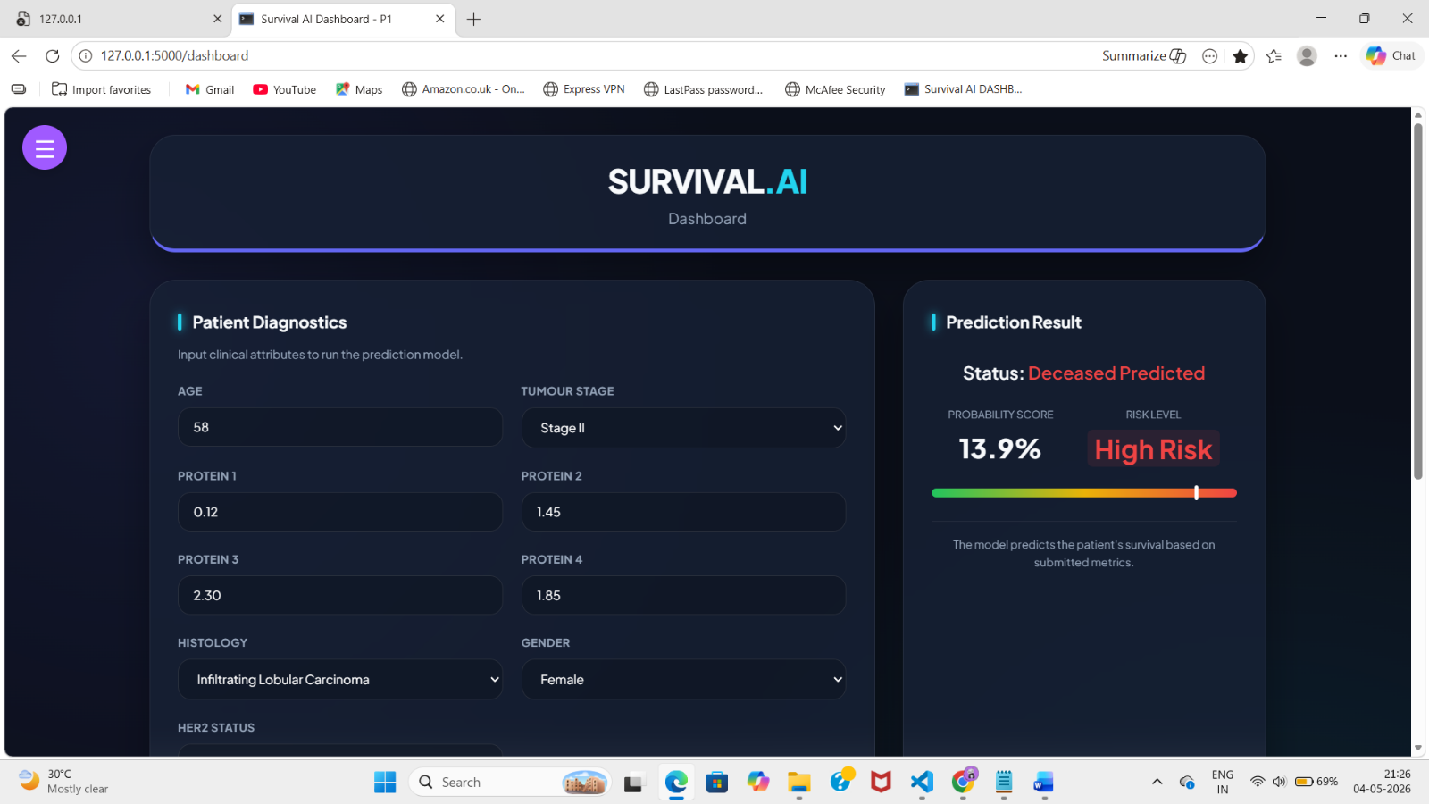
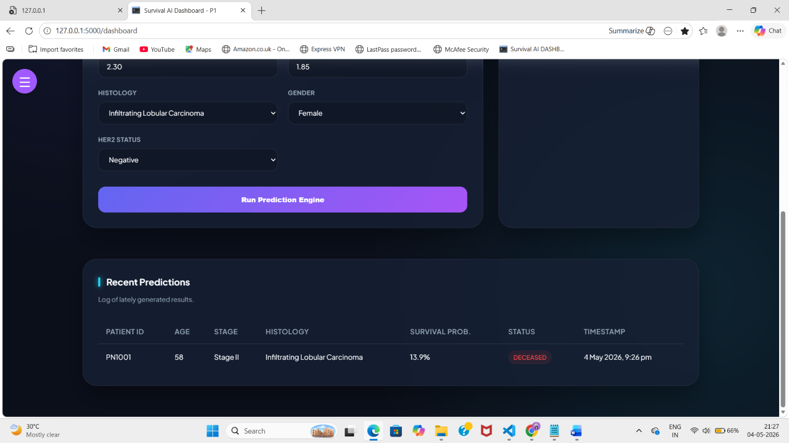
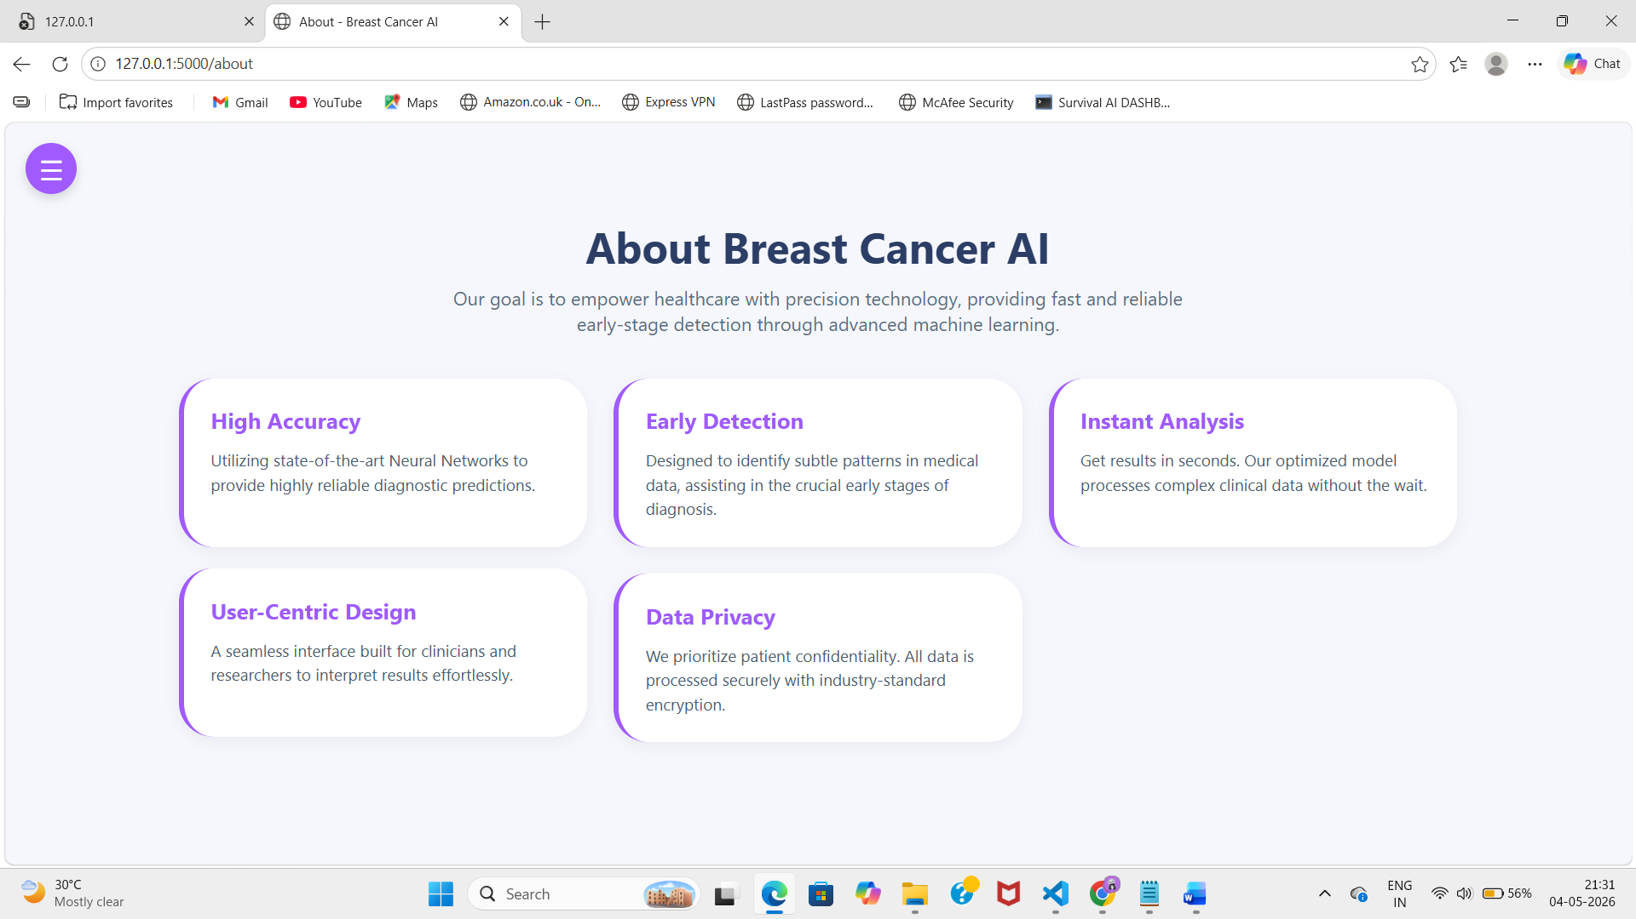
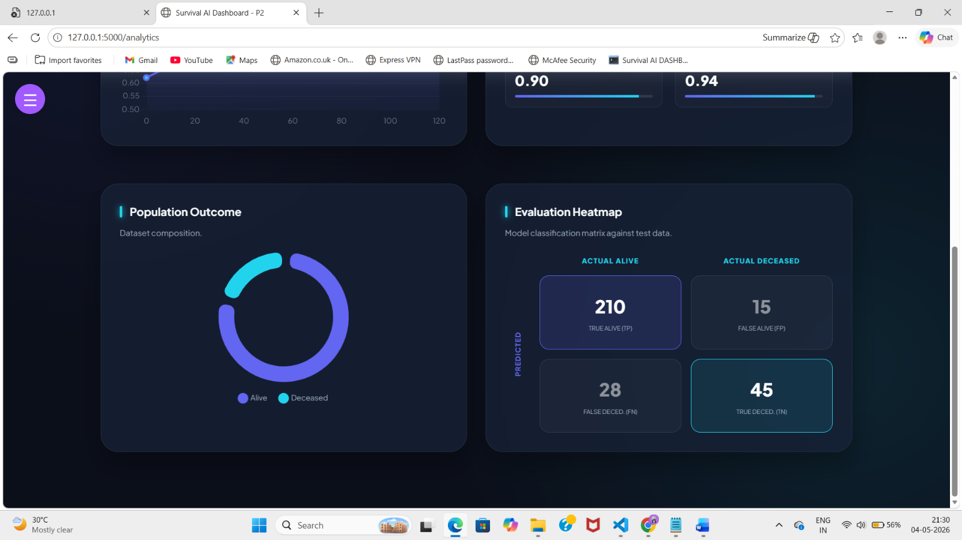
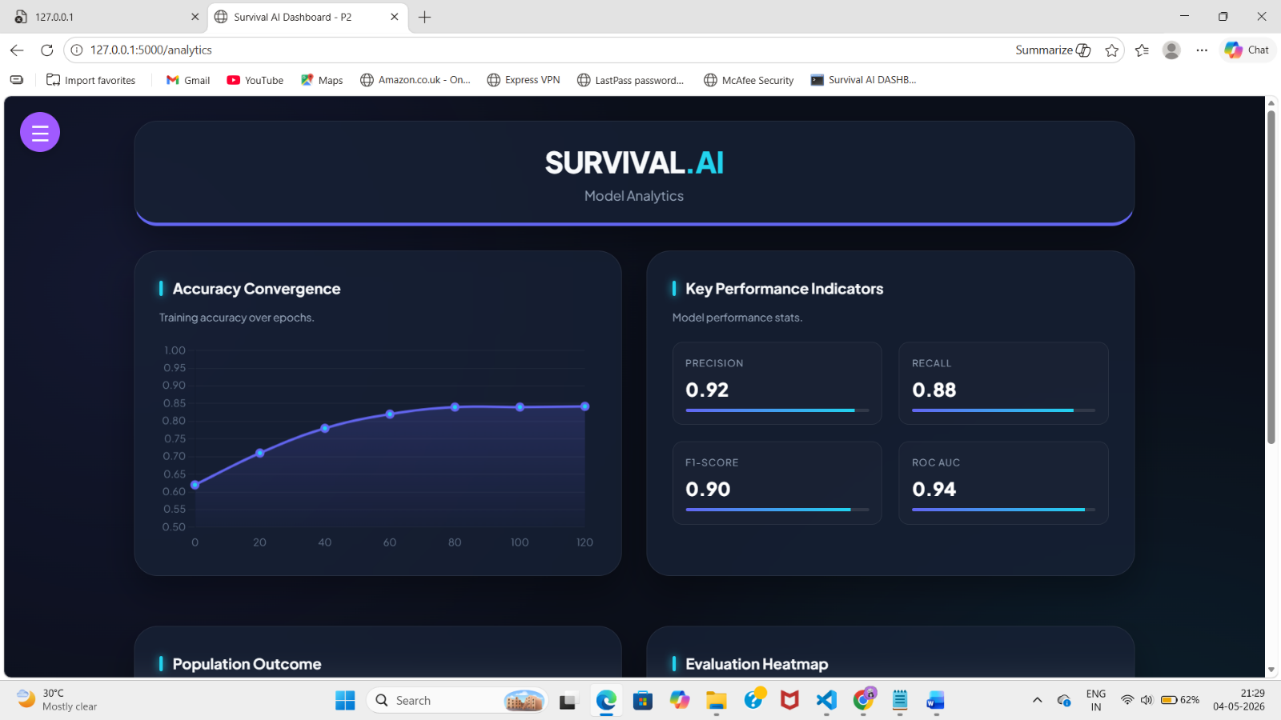

Chapter 5
Project Plan

1. 📖 Planning & Requirement Analysis
- Understand problem statement
- Define objectives and scope
- Collect dataset (breast cancer data)

2. 📊 Data Collection & Preprocessing
- Load dataset using Pandas
- Handle missing values
- Perform data cleaning
- Feature selection & scaling

3. 🔍 Exploratory Data Analysis (EDA)
- Visualize data using graphs
- Identify patterns and correlations
- Understand important features

4. 🤖 Model Development
- Train models (Logistic Regression, Decision Tree, Random Forest)
- Split data into training and testing sets
- Tune hyperparameters

5. 📈 Model Evaluation
- Evaluate using accuracy, precision, recall, F1-score
- Compare models
- Select best-performing model

6. 🖥️ Implementation
- Build simple UI (optional: web app using Flask/Streamlit)
- Integrate trained model
- Test prediction system

7. 🧪 Testing & Validation
- Test with new inputs
- Validate results
- Fix bugs and improve performance

8. 📄 Documentation & Final Submission
- Prepare project report
- Add diagrams (DFD, flowchart, wireframe)
- Final presentation (PPT)

  - List of Major Activities
- Collect and understand breast cancer survival dataset.
- Perform exploratory data analysis and identify usable features.
- Clean missing values and encode categorical attributes.
- Train candidate machine learning models.
- Evaluate models and select a suitable final model.
- Serialize model and preprocessing pipeline.
- Develop Flask backend and prediction route.
- Design dashboard and connect frontend with backend.
- Test prediction behaviour and update recent prediction table.
- Prepare report, conclusion, and references.

5.2 Gantt chart:-
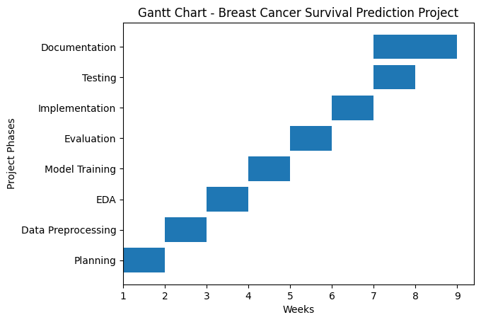

“Week-wise Project Execution Plan”

Activity | Estimated Duration (Days)
Requirement Analysis | 2 Days
Data Collection | 2 Days
Data Preprocessing | 4 Days
Exploratory Data Analysis (EDA) | 3 Days
Feature Engineering | 3 Days
Model Training | 4 Days
Model Evaluation | 2 Days
Hyperparameter Tuning | 3 Days
Implementation (UI Integration) | 4 Days
Testing & Validation | 2 Days
Documentation & Report | 3 Days

5.3 Estimated Time Duration (Days)

📊 Total Estimated Time
👉 32 Days (Approx.)

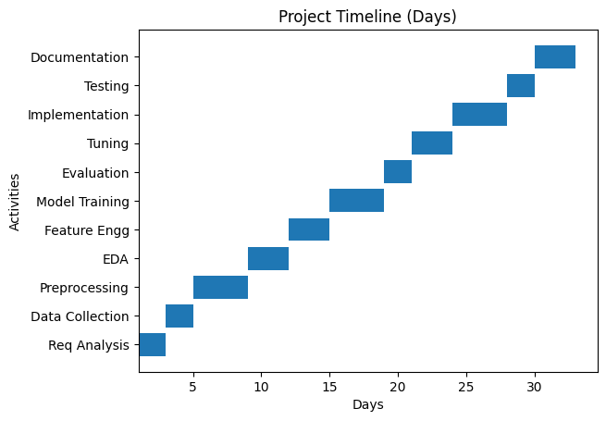

“Detailed Day-wise Activity Breakdown”

Key Highlight:
- Total Duration: ~32 Days
- Covers all phases: Data → Model → Deployment
- Structured for efficient project completion

Chapter 6
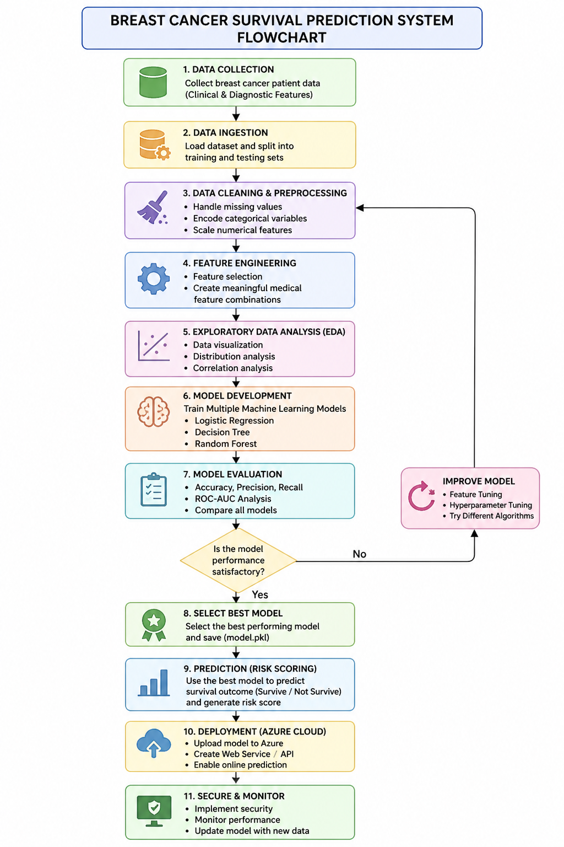
Implementation Details

6.1 Flow Chart
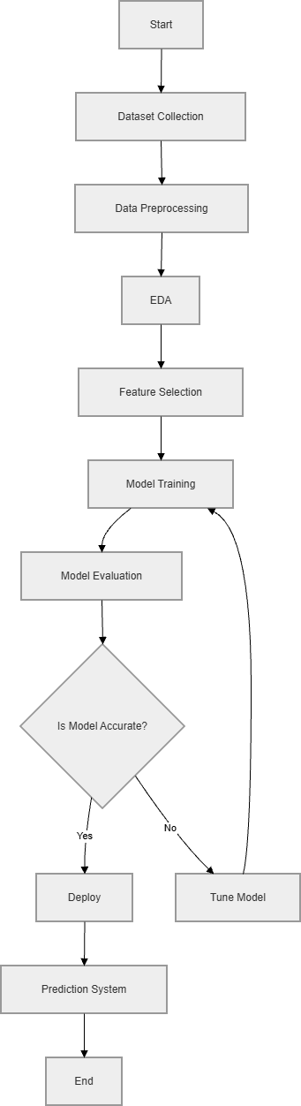

Prediction Flow chart
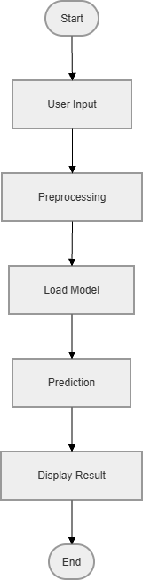

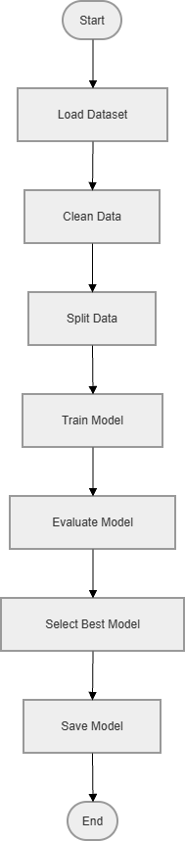
Train Flow Chart
Architecture Diagram

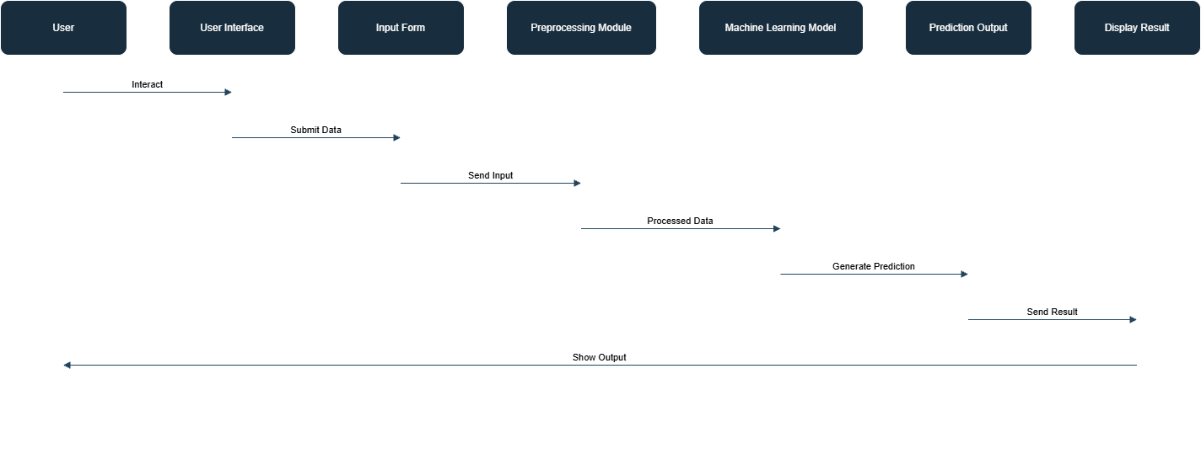

DFD Level 0
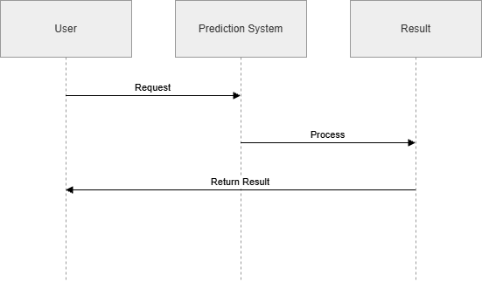

DFD Level 1

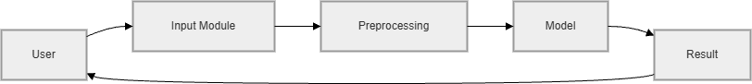

6.2 Understanding the Dataset
The dataset contains demographic, clinical, biomarker, tumour, treatment, and patient outcome fields. The target column is Patient_Status, mapped as Alive = 1 and Dead = 0 during training. In the final dashboard model, only the fields visible to the user are used for prediction.
Feature | Type | Use in Final Dashboard Model
Age | Numerical | Patient age at the time of record
Protein1 | Numerical | Protein biomarker
Protein2 | Numerical | Protein biomarker
Protein3 | Numerical | Protein biomarker
Protein4 | Numerical | Protein biomarker
Gender | Categorical | Patient gender
Tumour Stage | Categorical | Stage I, II, or III
Histology | Categorical | Cancer histology category
HER2 status | Categorical | HER2 positive or negative

6.3 Data Visualization
Data visualization supports understanding of class distribution, feature ranges, and performance metrics. In the dashboard, population outcome is shown through a doughnut chart, training behaviour is represented through an accuracy line chart, and prediction quality is summarized using KPI cards and a classification heatmap.

6.4 Data Cleaning & Preprocessing
The preprocessing pipeline handles missing numerical values with median imputation and scales them using StandardScaler. Categorical values are filled using the most frequent value, encoded with OneHotEncoder, and scaled with StandardScaler configured for sparse-style encoded features. This same saved preprocessing object is reused during live prediction so training and inference remain consistent.

6.5 Model Development
Several candidate algorithms were considered, including Logistic Regression, Random Forest, Gradient Boosting, KNN, Decision Tree, AdaBoost, and CatBoost. During refinement, the KNN model was replaced because it produced repeated step-like probabilities. The final saved model was retrained using visible dashboard fields so predictions change according to patient input.
Model | Reason for Consideration | Observation
Logistic Regression | Simple baseline model with interpretable probabilities | Lower performance but useful baseline
Random Forest | Handles nonlinear relationships and feature interactions | Strong performance and stable behaviour
KNN | Distance-based classifier | Produced repeated probability steps such as 71.4 percent
Gradient Boosting | Sequential tree boosting for nonlinear patterns | Selected for input-sensitive probability output

6.6 Model Evaluation
The updated model was evaluated on the project test set after retraining with the selected dashboard feature set. The metrics below summarize the observed performance.

Metric | Value
Accuracy | 0.953
Precision | 0.945
Recall | 1.000
F1-score | 0.972
ROC-AUC | 1.000

6.6.1 Accuracy, Precision, Recall
Accuracy measures the total correct predictions, precision measures how many predicted Alive cases were actually Alive, and recall measures how many actual Alive cases were identified. The high recall indicates that the model identifies surviving patients effectively on the available test split.
Confusion Matrix | Predicted Dead | Predicted Alive
Actual Dead | 9 | 3
Actual Alive | 0 | 52

6.6.2 ROC-AUC Analysis
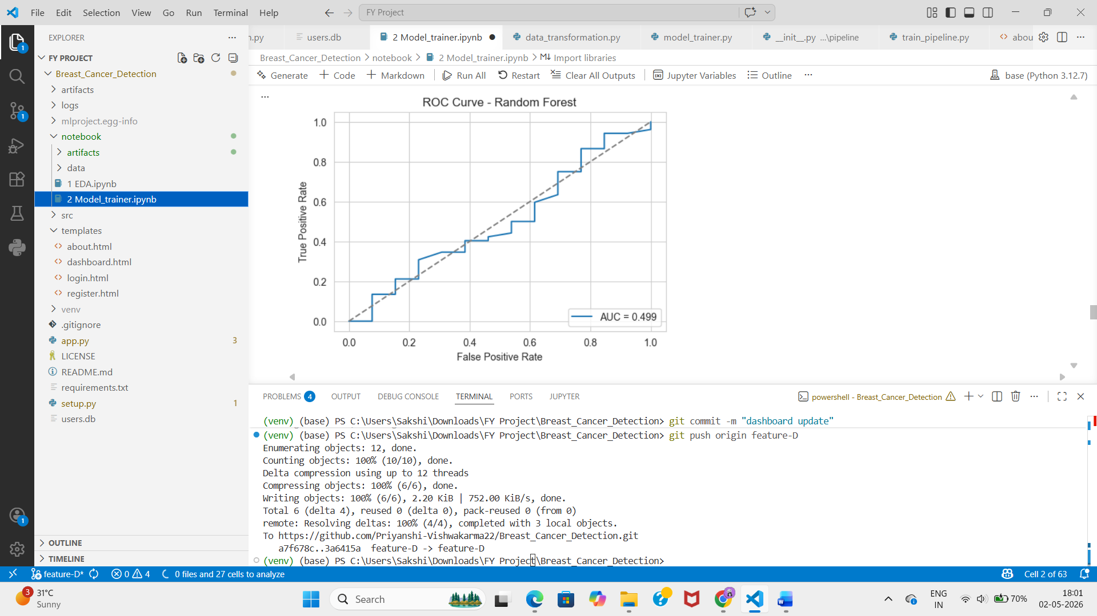

ROC-AUC evaluates the model's ability to separate Alive and Dead classes across probability thresholds. The observed ROC-AUC score on the current test split is 1.000. Since the dataset is limited, this value should be interpreted carefully and validated with larger external data before real clinical use.

6.7 Selection of Best Model
The selected model is Gradient Boosting because it provides probability outputs that respond to input changes more smoothly than KNN. This is important for the dashboard because users expect the survival probability and risk level to change when clinical inputs are changed.

6.8 Risk Scoring System
Survival Probability | Risk Level | Dashboard Meaning
70 percent and above | Low Risk | Patient has comparatively higher predicted survival probability.
40 percent to 69.9 percent | Medium Risk | Patient should be monitored carefully.
Below 40 percent | High Risk | Patient has lower predicted survival probability and requires attention.
.

Risk score is computed as 100 minus survival probability. The frontend positions the risk indicator on a green-to-red slider and logs the result in the recent predictions table.

Chapter 7
Cloud Deployment
The application can be deployed on Render by hosting the Flask server, Python environment, templates, static files, and model artifacts.

7.1 Render Setup
- Create an account on Render
- Push project to GitHub (app.py, templates/, static/, requirements.txt, artifacts/)
- Create New Web Service and connect repo
- Set:
  - Build: pip install -r requirements.txt
  - Start: gunicorn app:app
- Add environment variables (SECRET_KEY, FLASK_ENV)
- Deploy and test /login, /dashboard, /predict

Chapter 8
Security Implementation

Security is implemented at the application level through user registration, password hashing, and session-based access control. The dashboard and about page require a logged-in session. Passwords are stored using hashing rather than plain text.
Security Feature | Implementation
Password Hashing | Werkzeug generate_password_hash and check_password_hash are used.
Session Control | Flask session stores logged-in username and protects dashboard pages.
Input Validation | Backend validates age and builds a fixed feature dataframe.
Route Protection | Dashboard and About redirect to login if user is not authenticated.
Data Privacy Note | Prototype uses local SQLite and should be hardened before production use.

Chapter 9
Conclusion

The Breast Cancer Survival Prediction System successfully integrates a machine learning model with a Flask web dashboard. The system accepts patient data, transforms it through a saved preprocessing pipeline, predicts survival outcome, calculates probability and risk level, and displays recent prediction history on the dashboard.
During implementation, the model and dashboard were refined so that prediction results change according to patient input. Non-informative user-facing fields such as ER status, PR status, and Surgery Type were removed from the dashboard. Flask routing was also corrected so the About page connects properly from the dashboard sidebar.
Future work can include larger datasets, external validation, model explainability, database-backed prediction history, production cloud deployment, and doctor-facing interpretation notes.

Chapter 10
References

- Project source code: Breast_Cancer_Detection Flask and machine learning pipeline.
- Scikit-learn documentation for preprocessing, model training, and metrics.
- Flask documentation for routing, templates, sessions, and JSON APIs.
- Pandas documentation for dataset loading and dataframe operations.
- Academic lecture notes and practical implementation work for machine learning project development.

